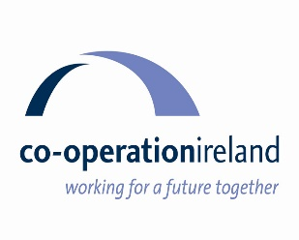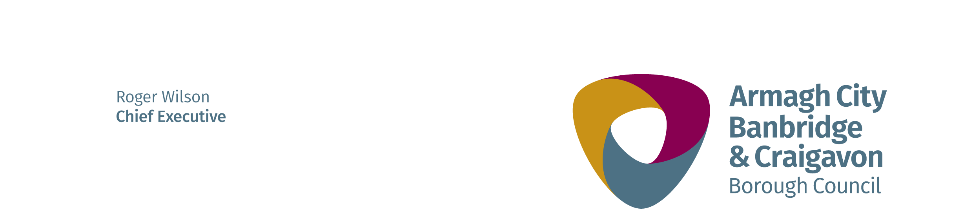

**IPB PRIDE OF PLACE COMMUNITY AWARDS 2025**

**Armagh Banbridge Craigavon Borough Council in conjunction with Cooperation Ireland IPB Pride of Place 2025 are proud to present the prestigious Pride of Place Competition.**

This is a competition that acknowledges the efforts and endeavours of communities throughout the island of Ireland to make their place the best place in which to live. The competition is open to all community groups through a range of categories and the common thread to applications is the impact and difference made in people’s lives.

The purpose of the competition is to acknowledge the fantastic work being done every day by communities and Armagh City, Banbridge & Craigavon Borough Council would like to encourage all local community groups to showcase their great achievements and submit an Expression of Interest.

These awards are designed to recognise and thank community groups who make a valuable impact and contribution to community life.

**Nominate Now for the IPB Community Awards 2025:**

Do you think your Group is so inspiring they deserve to be recognised with an award?

Groups applying can be from any walk of life and any part of the Armagh City, Banbridge and Craigavon Borough Council area. This is an opportunity for you to nominate your Group and tell your story. It is a chance to acknowledge the tireless and selfless work carried out in your local community.

We want to hear about your Group now, it’s free and easy to apply.

Simply fill in and submit this expression of interest form right away!

**Criteria for submitting an application to any category are as follows:**

1. Applications will only be accepted from formally constituted, community managed and autonomous organisations (both new and previous applicants will be accepted).
2. A group may submit a maximum of one application per group.
3. All Groups are required to have a minimum of one year’sinvolvement in the activity for which they are being nominated and the activity must have taken place within the last three years.
4. Groups voluntary work must be of benefit to the people and life of the Borough.
5. Council will select 3 Groups to go forward to the Pride of Place Awards and will aim to represent each of the Armagh, Banbridge and Craigavon Areas – subject to applications received.
6. Groups selected will be expected to complete a more detailed submission to Pride of Place organisers in June. Council staff will support groups through this process
7. Groups will be required to submit an entry photograph with their application. The photograph should be 1MB in file size and supplied at a minimum of 1478px X 1240px, this can be found in the properties of the document. We strongly recommend to avoid supplying photographs taken with camera phones as the file size and quality often tend to be insufficient for reproduction in the Souvenir Brochure

# ****IPB PRIDE OF PLACE 2025****

# ****EXPRESSION of Interest****

# ****Awards categories****

Please read the **Criteria** carefully before making an application. If you feel that the organisation meets with the criteria then select the category that best applies to your **group/organisation.**

**Select the category you would like to enter the group in.**

|  |  |
| --- | --- |
| Population 0 - 300 |  |
| Population 300 - 1000 |  |
| Population 1001 - 2000 |  |
| Population 2001 – 5000 |  |
| Population over 5000 |  |
| Creative Communities |  |
| CLIMATE ACTION AND BIODIVERSITY |  |
| Community Youth Initiative |  |
| Inclusive Communities |  |
| Community Wellbeing Initiative |  |
| Community Tourism Initiative |  |
| Urban Neighbourhoods and Housing Estates |  |
| Age Friendly Communities |  |
| CITIES COMPETITION (GROUPS BASED IN ARMAGH CITY) | if applicable tick this box and select a category as above |

## scoring criteria

|  |  |  |
| --- | --- | --- |
| Assessment Criteria |  |  |
| Impact | 0-5 |
| Evidence of need & innovation demonstrated | 0-5 |
| Fit with Council Priorities & impact on the target group/wider community | 0-5 |
| Collaboration | 0-5 |
| Sustainability | 0-5 |

**Generic Guidance**

|  |  |  |
| --- | --- | --- |
| Analysis of Answer | Description | Score |
| The applicant failed to address the question. | Did not answer question | 0 |
| An unacceptable response with serious reservations. Limited detail. High risk that the programme objectives will not be met. | Very Poor | 1 |
| A response with reservations. Lacks convincing detail. Medium risk that the programme objectives will not be met. | Poor | 2 |
| Meets Requirements. The response generally meets the requirements but lacks sufficient detail to warrant a higher mark. | Good | 3 |
| A good response that meets the requirements. Demonstrates good understanding. | Very Good | 4 |
| Excellent response that meets the requirements. Indicates an excellent response with no obvious weaknesses. | Excellent | 5 |

Please complete your application as accurately and as fully as possible within the word limit available. The decision of the judging panel is final.

* Judging will be a 1 Stage process – Stage 1 - Assessment Scoring
* There will be a minimum of two Officers on the Assessment Panel
* Please note, the judging panel may (at their discretion) change your selection to the most appropriate category i.e. that best fits the nomination

## Council Priorities

Council’s Corporate Plan

The table below sets out Council’s commitments (or priorities) to help achieve the vision as set out in the plan. Applicants should consider this table and need to explain how their application can help further Council’s priorities:

|  |  |  |  |
| --- | --- | --- | --- |
| **ECONOMY** | Enterprising | Skilled | Tourism |
| * Business Start- up and growth. * Efficient connections. * Provide information, services and programmes. | * Employability skills and training. * Apprenticeships, work experience, volunteering. * Up to date skills and learning. | * Understanding visitors. * Create and develop a unique visitor proposition and brand. * Quality visitor experiences through places, accommodation & attractions. |
|  | | | |
| **COMMUNITY** | Confident | Healthy | Welcoming |
| * Empower communities to contribute to decisions. * Community activities and events. * Safe, accessible and welcoming facilities. | * Work with partners to reduce inequalities in health. * Provide a range of quality. opportunities for everyone to be active and healthy. * Health protection and safety. | * Empower communities to respect each other, build relationships, grow together. * Shape and design places that value diversity. * Include everyone in community life. |
|  | | | |
| **PLACE** | Enhanced | Creative | Revitalised |
| * Increased understanding and respect of environment. * Develop and enhance our assets in sustainable way. * Promote civic pride and access to our local places. | * Seek investment to preserve uniqueness of our heritage. * Increase participation in arts and culture. * Improve accessibility to creative experiences. | * Tackle physical and social deprivation. * Secure investment in infrastructure and connectivity. * Attractive, healthier, safer, cleaner neighbourhoods. |

# ****Return of nominations.****

Expressions of interests should be returned via email to **Diane Stinson** and must be received by **4pm** on **Monday 28th April 2025** in order to be considered for the Pride of Place awards 2025 Email: [Diane.Stinson@armaghbanbridgecraigavon.gov.uk](mailto:Diane.Stinson@armaghbanbridgecraigavon.gov.uk)

All EOI’s received after this date will not be considered. The judge’s decision is final and no correspondence will be entered into.

**For further information, please contact**

**Diane Stinson, Community Development Department, Palace Demesne,**

**Armagh BT60 4EL.**

**Email:** [diane.stinson@armaghbanbridgecraigavon.gov.uk](mailto:diane.stinson@armaghbanbridgecraigavon.gov.uk)

Mobile **Telephone Number: 07786517767**

# ****IPB PRIDE OF PLACE COMMUNITY AWARDS 2025 APPLICATION FORM****

### Group Details

|  |  |
| --- | --- |
| Award Category |  |
| Group Name |  |
| Contact Person |  |
| Address |  |
| City/Town |  |
| County |  |
| Post Code |  |
| Telephone |  |

**Signed: _______________________________________________________**

**Date: _______________________________________________________**

**Describe your area or initiative and achievements/activities to date which have had an impact on your local area** (Max 300 words)

Describe how the group uses an innovative approach to meet need under the Award

category applied for? (Max 300 words)

# Please describe what impact the group makes to the local community/target group in accordance with the council’s corporate priorities? (Max 200 words)

|  |
| --- |
|  |

# **Describe how you reach out and collaborate with other groups and the wider community in your area? (Max 300 words)**

|  |
| --- |
|  |

# **Describe any plans for the future development of your area/initiative and how you will ensure sustainability? (Max 300 words)**

|  |
| --- |
|  |