**Social Housing Statistics**

The levels of social housing need are assessed and monitored by the Northern Ireland Housing Executive (NIHE). Social Housing is housing that is provided at an affordable rent by the Housing Executive and registered housing associations; that is, housing associations that are registered and regulated by the Department for Communities (DfC) as a social housing provider.

The five-year assessment for Armagh City, Banbridge and Craigavon Borough for 2023-28 shows a need for an additional 1,498 units over this period.

*Figure 1: Social housing need in Armagh City, Banbridge and Craigavon Borough 2014-19 to 2023-28. Source: Northern Ireland Housing Executive.*

With an additional 1,498 units required in the Armagh City, Banbridge and Craigavon Borough between 2023-28, figure 2 shows this need by settlement area within the borough. North Lurgan and Portadown 2 exhibit the highest levels of social housing need in the borough with 316 and 229 units required respectively. Those settlements with a need less than 10 have been grouped together and have a total need of 66.

*Figure 2: Social housing need in Armagh City, Banbridge and Craigavon Borough by settlement 2023-28. Source: Northern Ireland Housing Executive.*

The NIHE waiting list can be used to determine the pressure for social housing in an area. NIHE holds data on all housing applications and allocations (‘the waiting list’) made through the Common Selection Scheme in their Housing Management System.

As at March 2024, there were 3,916 applicants on the waiting list in Armagh City, Banbridge and Craigavon Borough.

Of these applicants, 2,470 (or 63.1%) were in housing stress (where they have 30 or more points under the Common Selection Scheme.) The number of applicants on the waiting list and the number in housing stress has increased over the past year and the number of applicants in housing stress is currently the highest it has been of the years presented.

A total of 481 applicants were allocated social housing in the borough in the year ending March 2024, an increase on the previous year.

*Figure 3: Social housing waiting list trends, Armagh City, Banbridge and Craigavon Borough 2014 to 2024. Source: Northern Ireland Housing Executive.*

Table 1 presents a breakdown of the applicants and allocations by household type (definitions of each of the household types are provided on the following page). Single persons account for more than 40% of all applicants with small families (24%) and older persons (15%) the next biggest groupings. Of the 950 small family applicants, more than 65% were in housing stress. Approximately 64% of the single person applicants were in housing stress while 59% of the older person households were in housing stress.

There was a total of 481 allocations in the year up to March 2024 and one third of these (159) were houses allocated to small families. Single persons were allocated 154 houses (32%) and older persons had the next biggest allocation at 84 or 17.5% of all allocations.

|  |  |  |  |  |  |  |  |
| --- | --- | --- | --- | --- | --- | --- | --- |
| Type | Single Person | Small Adult | Small Family | Large Adult | Large Family | Older Person | Total |
| Applicant | 1,622 | 229 | 950 | 154 | 361 | 600 | **3,916** |
| Applicant in Housing Stress | 1,043 | 127 | 619 | 99 | 228 | 354 | **2,470** |
| % of Applicants in Housing Stress | 64.3% | 55.5% | 65.2% | 64.3% | 63.2% | 59.0% | **63.1%** |
| Allocation | 154 | 16 | 159 | 20 | 48 | 84 | **481** |

*Table 1: Waiting list at March 2024 in Armagh City, Banbridge and Craigavon Borough. Source: Northern Ireland Housing Executive.*

The household breakdown of the 2,470 applicants in housing stress shows 1,043 (42%) were single person households, 619 (25%) were small family households and 354 (14%) were older person households.

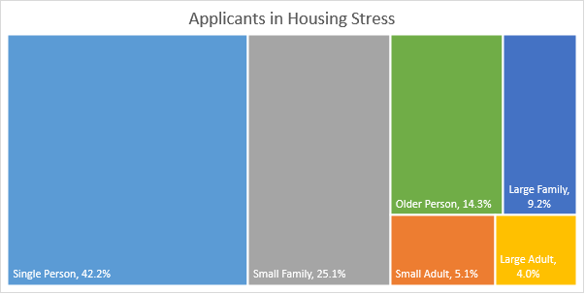*Figure 4: Composition of housing stress applications at March 2024 (i.e. 30 points or more) in Armagh City, Banbridge and Craigavon Borough. Source: Northern Ireland Housing Executive.*

|  |  |
| --- | --- |
| **Household Type** | **Definition** |
| Single person | 1 person 16-59 years old |
| Older person | 1 or 2 persons aged 16 or over, at least 1 over 60 |
| Small adult | 2 persons 16-59 years old |
| Small family | 1 or 2 persons aged 16 or over, with 1 or 2 children |
| Large family | 1 or 2 persons aged 16 or over, and 3 or more persons 0-15, or 3 or more persons 16 or over and 2 or more persons aged 0-15 |
| Large adult | 3 or more persons aged 16 or over with or without 1 person aged 0-15 |

*Table 2: Household Types Definitions. Source: Northern Ireland Housing Executive.*

Further information on social housing can be found via the following links:

<https://www.nihe.gov.uk/Working-With-Us/Partners/Commissioning-prospectus>

<https://www.nihe.gov.uk/Working-With-Us/Partners/Housing-Investment-Plans-(HIPS)>