Northern Ireland Multiple Deprivation Measure 2017 Overview
Introduction
Measures of spatial distribution of deprivation have been developed and used in Northern Ireland since the 1970s, and have played a central role in terms of informing the targeting of resources to the most deprived areas in Northern Ireland.
The purpose of this document is to give an overview of what the Northern Ireland Multiple Deprivation Measure is and to introduce the latest set of spatial deprivation measures (NIMDM 2017), published on 23rd November 2017, replacing those published in 2010, specifically related to those areas within Armagh City, Banbridge and Craigavon Borough. The new measures have been updated using the same broad methodological approach since 2001, but have taken advantage of new and better data sources.
As in previous iterations, the NIMDM 2017 provide information for seven distinct types of deprivation, known as domains, along with an overall multiple deprivation measure (MDM). The NIMDM 2017 comprises of 38 indicators in total. More in-depth information for each of the domains can be found in the Deprivation sub-section of the Armagh City, Banbridge and Craigavon Borough Councils Statistics page.
The NIMDM 2017 provide a mechanism for ranking areas within Northern Ireland in the order of the most deprived to the least deprived. However, they do not quantify the extent to which one area is more or less deprived than another.
In considering the relative ranks of areas, it is important to acknowledge that there will be:
- Areas which have been ranked as the most deprived, which have people living there who may not be regarded as deprived; and
- Areas which have been ranked as least deprived, which may have people living there who may be regarded as deprived.
How are the NIMDM 2017 measures constructed?
Northern Ireland is split into 890 spatial areas known as Super Output Areas (SOAs), with an average population of around 2,100 people. There are 87 SOAs within Armagh City, Banbridge and Craigavon Borough.

Through interaction with a range of organisations, expert groups and the general public, a total of 38 indicators were identified to capture different types of deprivation while conforming to a number of agreed criteria that had to be met.
Distinct types, or domains, of deprivation are made up from one or more indicators. The seven domains of deprivation are:
- Income Deprivation Domain
- Employment Deprivation Domain
- Health Deprivation and Disability Domain
- Education, Skills and Training Deprivation Domain
- Access to Services Domain
- Living Environment Domain
- Crime and Disorder Domain
The number of indicators in each domain range from one to nine as shown below.

The indicators in each domain were analysed to produce a domain specific deprivation ranking of the 890 SOAs in Northern Ireland, from 1 (most deprived) to 890 (least deprived).
The ranks of the seven domains were weighted and combined, to provide a ranking of multiple deprivation for the 890 SOAs.
The weights used when combining the individual domains of deprivation into the overall multiple deprivation measure were identical in the 2001, 2005 and 2010 Measures. The weights were originally set in the 2001 Multiple Deprivation Measure, largely based on theoretical considerations that (a) income and employment domains should carry more weight that the other domains, and (b) the domains with the most robust indicators should be given greater weight.

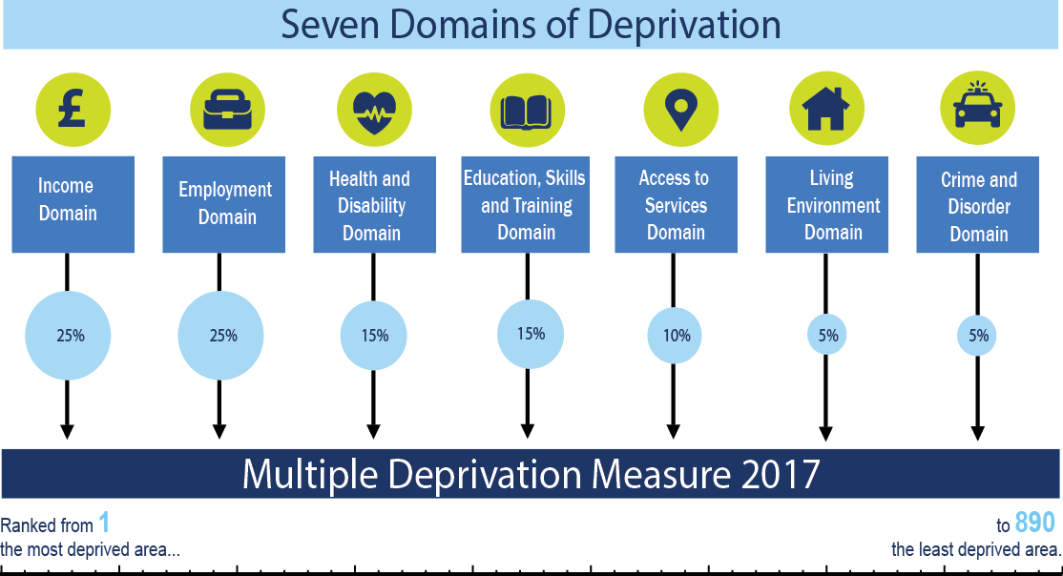

How can the NIMDM 2017 be used?
What the NIMDM 2017 can be used for –
For each individual domain of deprivation and the overall MDM, the rankings can be used to:
- Explore the relative deprivation of small geographical areas by comparing them with each other.
- Explore which small geographical areas are the most or least deprived.
- Examine the spatial distribution of small geographical areas that are the most or least deprived, however defined.
- Explore which small geographical areas have joined, left or remained in the most or least deprived areas over time.
What the NIMDM 2017 cannot be used for –
- Identifying deprived individuals or groups of people – these are area based spatial measures.
- Quantifying the extent to which a small geographical area is deprived – they provide relative rankings of areas.
- Quantifying the extent to which one area is more or less deprived than another – they provide relative rankings of areas.
- Assessing how absolute deprivation in a small geographical area has changed over time – they provide a spatial ranking at a single point in time.
- Measuring affluence – lack of deprivation is not the same as being affluent.
- Undertaking UK comparisons – each UK country has a different set of indicators, time periods, domains and domain weights.

Main improvements in NIMDM 2017
Income Deprivation Domain: Using income data instead of benefit data.

Employment Deprivation Domain: Including people with no income from employment, nor benefits associated with employment deprivation.
Health Deprivation and Disability Domain: Including people on multiple and repeat prescriptions to reflect complex and prolonged health needs.

Access to Services Domain: Using data relating to travel times to a wider variety of services by both private and public transport and access to broadband.

Living Environment Domain: New indicators on energy efficiency, road quality, flood risk, overcrowding and suitability of housing for the disabled.

Crime and Disorder Domain: Including an additional indicator relating to theft.

MDM compared with individual domains (Northern Ireland level)
The seven individual deprivation domains contribute to the MDM according to their weights. While the MDM provides an overall measure, it may mask some interesting and important variation in the domains.
NISRA encourages users to consider both the Multiple Deprivation Measure and individual domains, especially when targeting specific types of deprivation, or choosing the tools to improve overall deprivation.
Each set of circles below represent the 100 most deprived areas on the overall MDM and the 100 most deprived areas in each of the seven domains and show the extent to which they overlap. The overlap shows how many of the 100 most deprived areas in the overall MDM are also in the domain-specific 100 most deprived areas.
For example:
- The overlap is greatest for the Employment Deprivation Domain, sharing 83 areas with the MDM.
- The Income Deprivation Domain shares 61 areas with the MDM.
- The overlap is smallest for the Access to Services Domain, which shares four areas with the MDM.

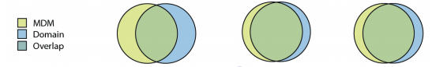
Income Deprivation Employment Deprivation Health Deprivation and Domain 61% Domain 83% Disability Domain 80%

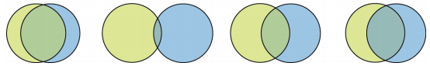
Educations, Skills & Access to Services Living Environment Crime and Disorder Training Deprivation Domain 4% Domain 35% Domain 54% Domain 68%

MDM compared with individual domains (Armagh City, Banbridge and Craigavon Borough level)
To look at both the Multiple Deprivation Measure and individual domains within the borough we have followed the diagram on the previous page. However, the circles will now represent the ten most deprived areas in Armagh City, Banbridge and Craigavon Borough on the overall MDM and each of the seven domains, and show the extent to which they overlap.
The overlap shows how many of the ten most deprived areas in Armagh City, Banbridge and Craigavon Borough in the overall MDM are also in the domain-specific ten most deprived areas.
For example:
- The greatest overlap in Armagh City, Banbridge and Craigavon Borough is shown in the Education, Skills and Training Deprivation Domain, sharing eight areas with the borough’s top ten MDM areas.
- Four of the domains share seven areas with the borough’s MDM – Employment Deprivation Domain, Health Deprivation and Disability Domain, Living Environment Domain and Crime and Disorder Domain.
- There is no overlap on the Access to Services Domain as the ten most deprived areas in the borough for this domain are rural, while the most deprived top ten for the borough’s MDM are all urban.
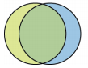
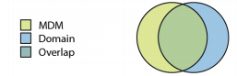
Income Deprivation Employment Deprivation Health Deprivation and Domain 60% Domain 70% Disability Domain 70%
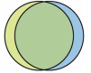
Education, Skills & Access to Services Living Environment Crime and Disorder Training Deprivation Domain 0% Domain 70% Domain 70% Domain 80%

A summary of the most deprived SOAs within Armagh City, Banbridge and Craigavon is provided on the following page, along with details of the overall MDM in the borough. More in-depth information for each of the domains can be found in the Deprivation sub-section of the Armagh City, Banbridge and Craigavon Borough Councils Statistics page.

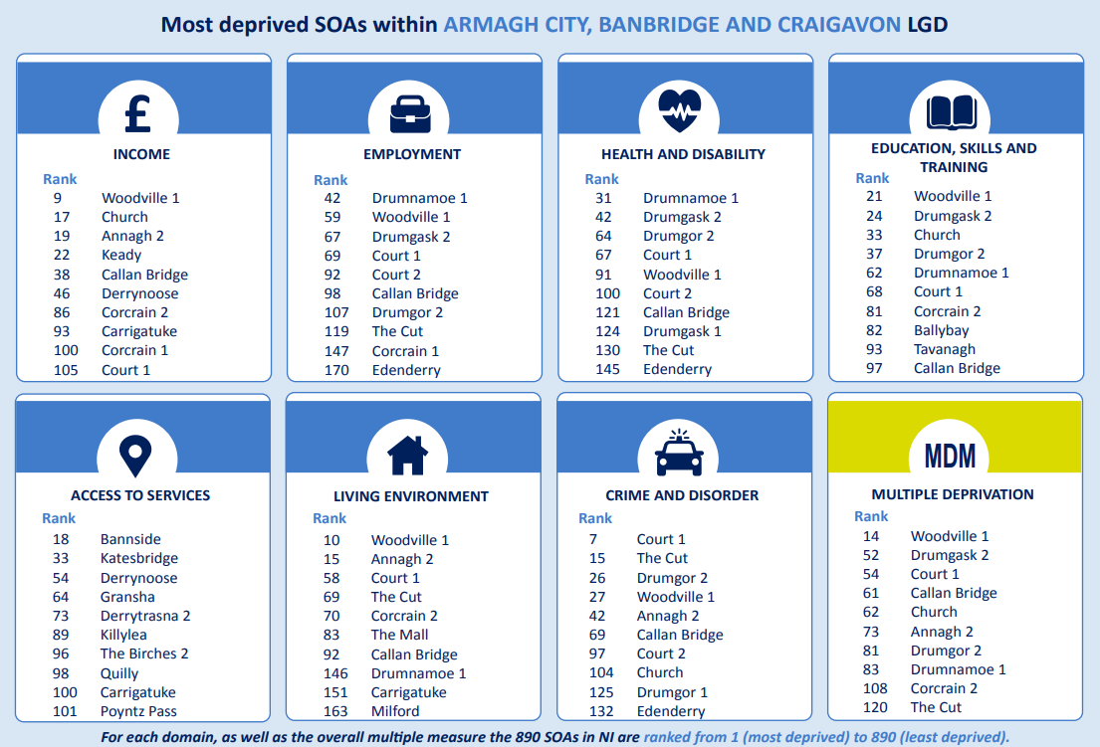

Multiple Deprivation Measure
The Multiple Deprivation Measure (MDM) combines the seven deprivation domains to rank areas based on multiple types of deprivation.
Looking at the 100 most deprived areas according to the MDM, eight of these SOAs are in Armagh City, Banbridge and Craigavon Borough (9% of the total SOAs in the borough).
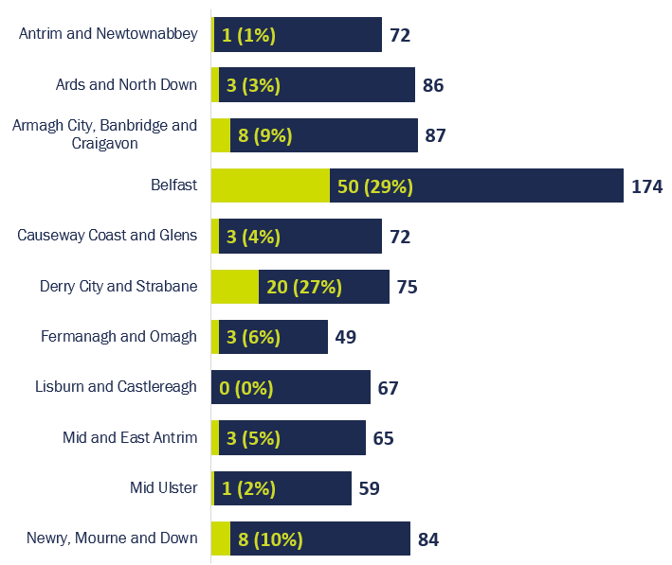
The SOAs in Armagh City, Banbridge and Craigavon Borough falling within the 20% most deprived in Northern Ireland according to the Multiple Deprivation Measure 2017 are shown below and mapped on the following page. While the top ten SOAs in the borough are all urban areas, rural areas in the borough experience deprivation. Keady SOA which is ranked 125th in Northern Ireland, and 11th in the borough, is the 9th most deprived rural SOA in Northern Ireland according to the MDM.
Top ten in the borough
NIMDM Rank (1=most deprived  890=least deprived) | Armagh City, Banbridge and Craigavon Borough SOA | Urban/Rural
14 | Woodville 1 | Urban
52 | Drumgask 2 | Urban
54 | Court 1 | Urban
61 | Callan Bridge | Urban
62 | Church | Urban
73 | Annagh 2 | Urban
81 | Drumgor 2 | Urban
83 | Drumnamoe 1 | Urban
108 | Corcrain 2 | Urban
120 | The Cut | Urban
125 | Keady | Rural
129 | Corcrain 1 | Urban
164 | Tavanagh | Urban

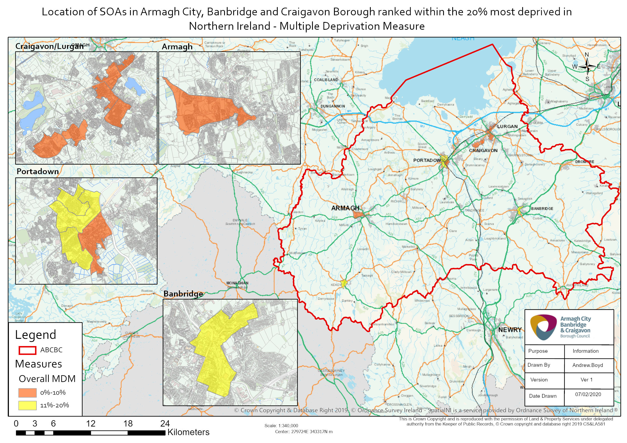

Further information on NIMDM 2017 can be found via the following link:
https://www.nisra.gov.uk/statistics/deprivation/northern-ireland-multiple-deprivation-measure-2017-nimdm2017

Description of indicators available at: https://www.nisra.gov.uk/publications/nimdm17-results
See page 6 of the NIMDM 2017 – Blue Print available at: https://www.nisra.gov.uk/publications/nimdm17-consultation-results
See page 44 of the Measures of Deprivation for Northern Ireland – Report 2001 available at: https://www.nisra.gov.uk/publications/northern-ireland-multiple-deprivation-measure-2001-nimdm2001

